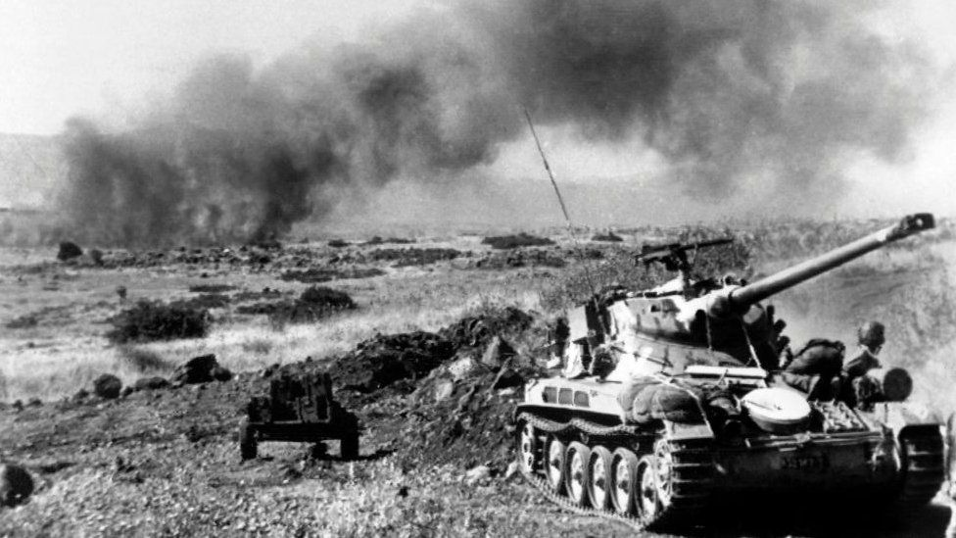image copyrightGetty Images
image captionIsraeli tanks in action on the Golan Heights

